FORM 5
THE PATENTS ACT, 1970
(39 of 1970)
and
THE PATENTS RULES, 2003
STATEMENT AND UNDERTAKING UNDER SECTION 8
(See section 10(6) and Rule 13(6))
1. NAME OF THE APPLICANT(S). | SVKM’s DWARKADAS J. SANGHVI COLLEGE OF ENGINEERING
hereby declare that the true and first inventor(s) of the invention disclosed in the complete specification filed in the pursuance of my/our application numbered Dated: 15th October 2024, Tuesday is/are
2. INVENTOR(S)
NAME: SHAH SHASHWAT NIMESH
NATIONALITY : INDIAN
ADDRESS : A/1606, SHREEPATI CASTLE, KHETWADI, GRANT ROAD(E), MAHARASHTRA.
MUMBAI - 400004
Dated : 15th October 2024, Tuesday
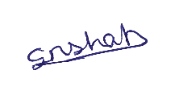
Signature:-
Name of Signatory:- SHAH SHASHWAT NIMESH

NAME: GANGWANI SAKSHI MAHESH
NATIONALITY : INDIAN
ADDRESS: HIGHLAND PARK, BUILDING NO. 9/104, THANE(W), MAHARASHTRA.
THANE - 400607
Dated: 15th October 2024, Tuesday
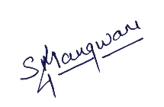
Signature:-
Name of Signatory:- GANGWANI SAKSHI MAHESH

NAME: NISHAR AKSH DILIP
NATIONALITY : INDIAN
ADDRESS: HARLALKA HEIGHTS, FLAT NO. 1301, SITARAM PODDAR MARG, MARINE LINES(E), MAHARASHTRA, MUMBAI-400002.
Dated : 15th October 2024, Tuesday

Signature:-
Name of Signatory:- NISHAR AKSH DILIP

NAME: KARANI RUHINA
NATIONALITY : INDIAN
ADDRESS: DEPARTMENT OF COMPUTER ENGINEERING, DWARKADAS J. SANGHVI COLLEGE OF ENGINEERING,
NO. U, 15, BHAKTIVEDANTA SWAMI RD, OPP. COOPER HOSPITAL, NAVPADA, JVPD SCHEME, VILE PARLE, MUMBAI, MAHARASHTRA 400056
Dated : 15th October 2024, Tuesday
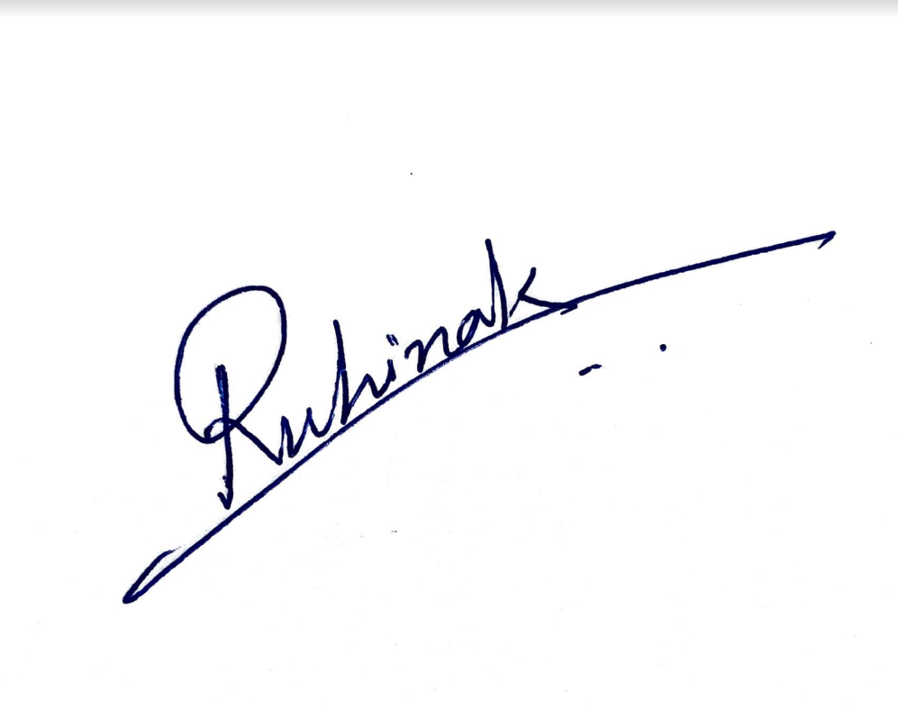
Signature:-
Name of Signatory:- KARANI RUHINA
NAME: DR. VASUDEVAN HARI
NATIONALITY : INDIAN
ADDRESS: 1103/04, NOVA A WING, AKRUTI NIHARIKA COMPLEX, N S PHADKE ROAD, SAIWADI, ANDHERI EAST, MUMBAI - 400069
Dated : 15th October 2024, Tuesday
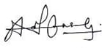
Signature:-
Name of Signatory:- DR. VASUDEVAN HARI

NAME: DR. NARVERKAR MEERA
NATIONALITY : INDIAN
ADDRESS: 801, THE RESIDENCY, OPPOSITE DECCAN SOCIETY, KHAR, DANDA, PALI HILL, BANDRA (W), MUMBAI - 400052
Dated : 15th October 2024, Tuesday
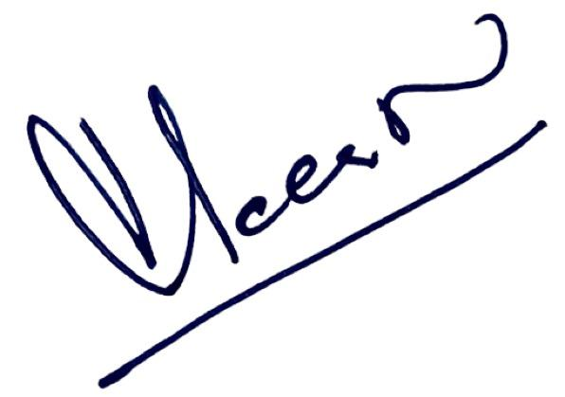
Signature:-
Name of Signatory:- DR. NARVERKAR MEERA

NAME: DR. GHAG KRANTI VITHAL
NATIONALITY : INDIAN
ADDRESS: 1703, SWARAJYA SRA CHS 17TH FLOOR, 6TH BUILDING OPPOSITE INDIAN CANCER SOCIETY, BHOIWADA, PAREL, MUMBAI – 400012, MAHARASHTRA, INDIA
Dated : 15th October 2024, Tuesday
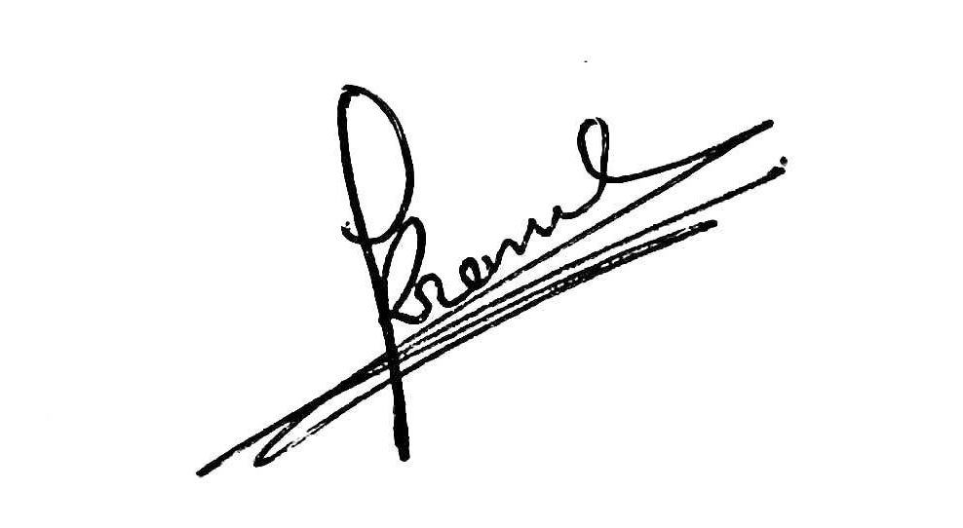
Signature:-
Name of Signatory:- DR. GHAG KRANTI VITHAL
SVKM’s Dwarkadas J. Sanghvi College of Engineering
Applicant

To,
The controller of Patent
The Patent Office, at Mumbai/Delhi/Chennai/Kolkata

